<https://www.youtube.com/watch?v=Di50Y5b20p8>

**api_example** was created to learn about working with APIs using the djangorestframework

<https://www.youtube.com/watch?v=263xt_4mBNc>

created apiproject virtual environment, installed packages use pip list

created api_example project C:\Users\goobb\Documents\python\django tutorials\api_example

downloaded ngrok which allows my localhost server to be accessible on the web through creating a “web tunnel”

C:\Users\goobb

<https://www.youtube.com/watch?v=GCIW-2RTcFY>

don’t close the command prompt below otherwise the tunnel won’t work

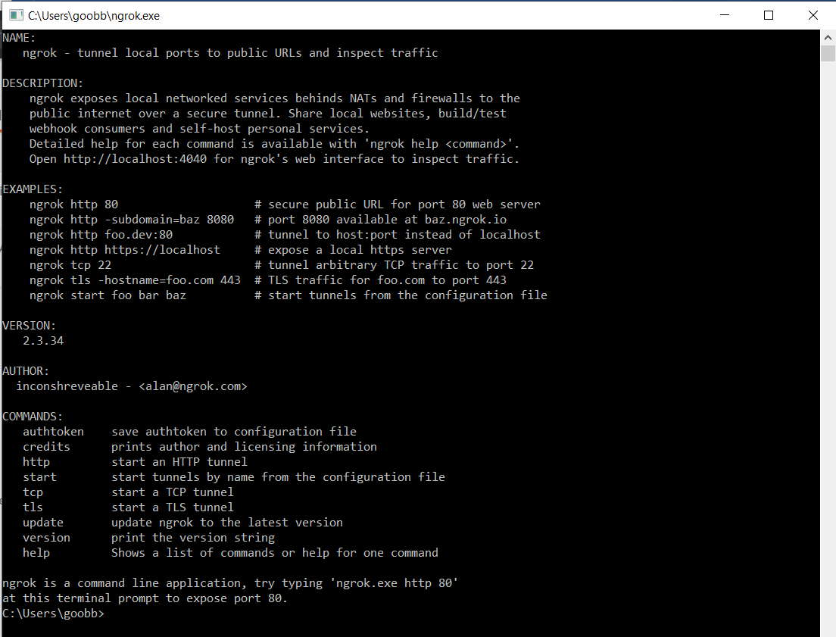

Installed the ShopifyAPI

<https://github.com/Shopify/shopify_django_app>